 | PATIENT  ENROLMENT FORM | PO Box 30, Waitara  P: 06 754 8119 F: 06 754 8461  E:practice@waitarahealth.co.nz

Provider: GP2GP: EDI: waitmcwa  Dr C Katzen NZMC: 28579 Dr N Reid NZMC: 61931 Dr R Shonowo NZMC: 63047  Dr B Wood NZMC: 20167 | NHI (Office use only)

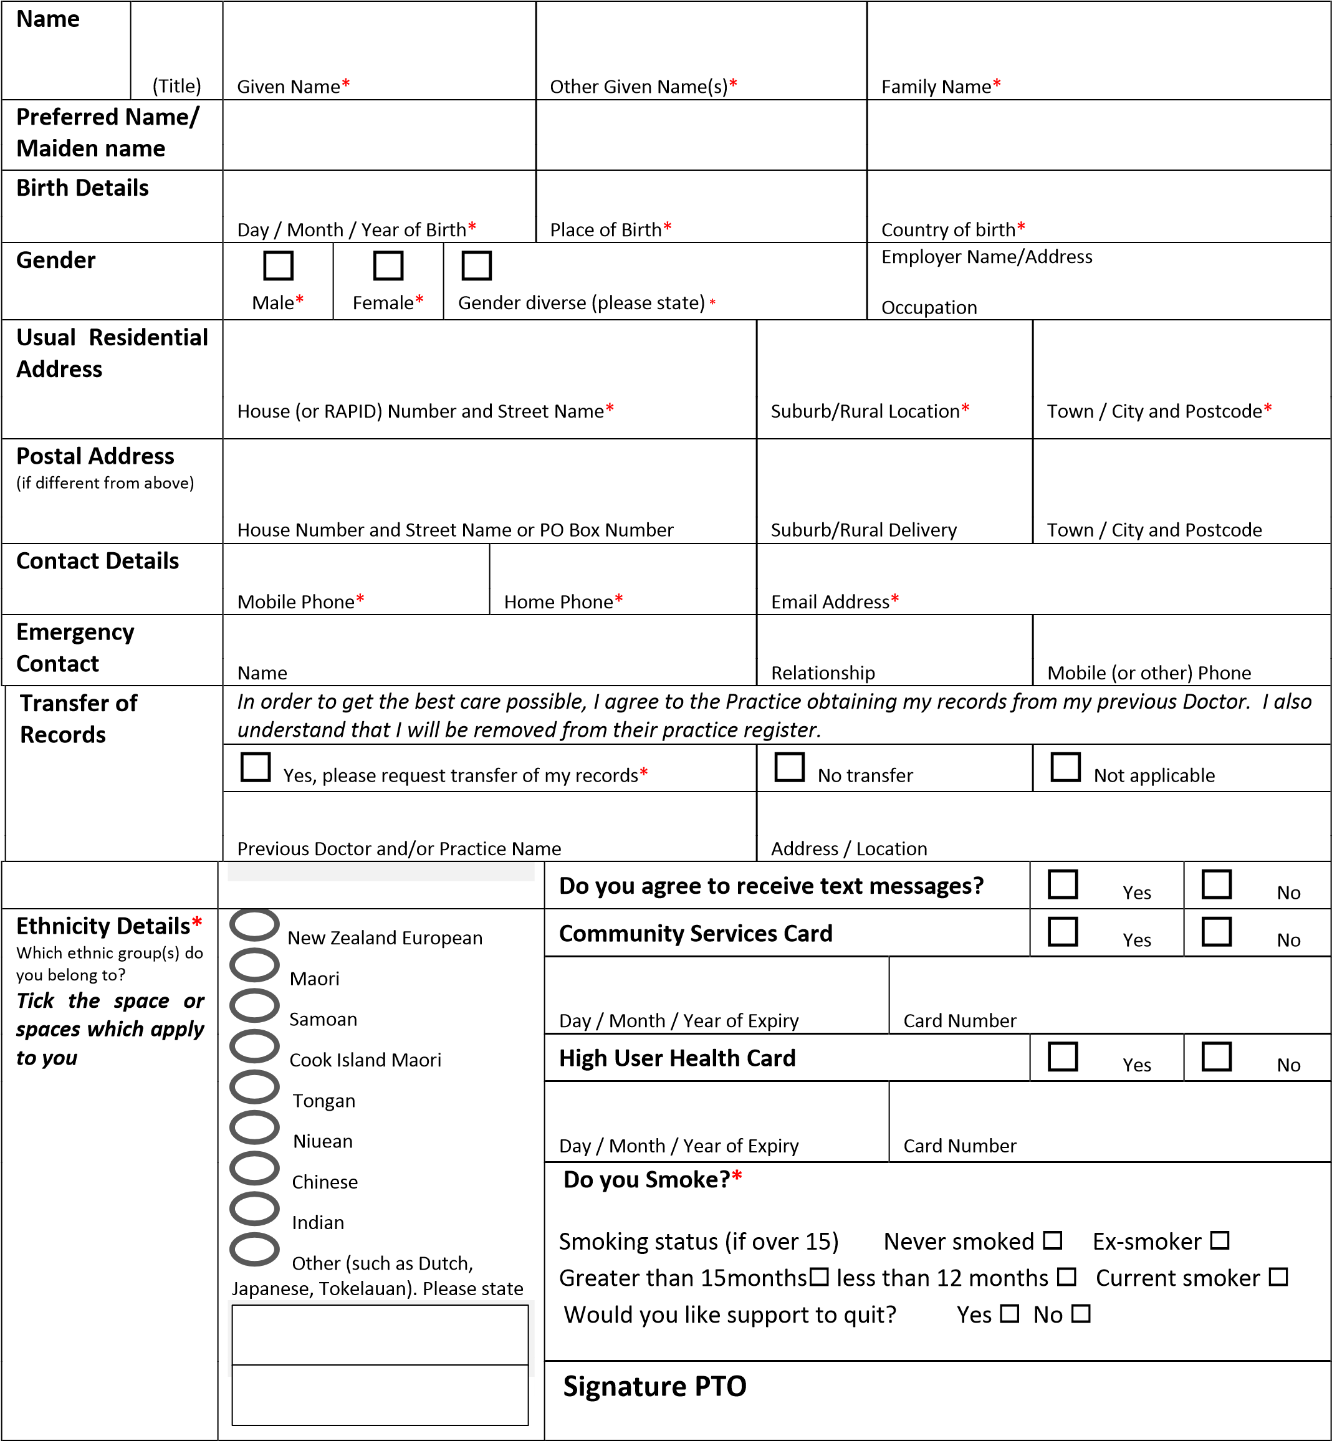

Primary Health Services Provider Enrolment Form Last Updated : 10 March 2020
My declaration of entitlement and eligibility

I am entitled to enrol because I am residing permanently in New Zealand.  The definition of residing permanently in NZ is that you intend to be resident in New Zealand for at least 183 days in the next 12 months | ◻
I am eligible to enrol because:
a | I am a New Zealand citizen (If yes, tick box and proceed to I confirm that, if requested, I can provide proof of my eligibility below) | ◻
If you are not a New Zealand citizen please tick which eligibility criteria applies to you (b–j) below:
b | I hold a resident visa or a permanent resident visa (or a residence permit if issued before December 2010) | ◻
c | I am an Australian citizen or Australian permanent resident AND able to show I have been in New Zealand or intend to stay in New Zealand for at least 2 consecutive years | ◻
d | I have a work visa/permit and can show that I am able to be in New Zealand for at least 2 years (previous permits included) | ◻
e | I am an interim visa holder who was eligible immediately before my interim visa started | ◻
f | I am a refugee or protected person OR in the process of applying for, or appealing refugee or protection status, OR a victim or suspected victim of people trafficking | ◻
g | I am under 18 years and in the care and control of a parent/legal guardian/adopting parent who meets one criterion in clauses a–f above OR in the control of the Chief Executive of the Ministry of Social Development | ◻
h | I am a NZ Aid Programme student studying in NZ and receiving Official Development Assistance funding (or their partner or child under 18 years old) | ◻
i | I am participating in the Ministry of Education Foreign Language Teaching Assistantship scheme | ◻
j | I am a Commonwealth Scholarship holder studying in NZ and receiving funding from a New Zealand university under the Commonwealth Scholarship and Fellowship Fund | ◻

I confirm that, if requested, I can provide proof of my eligibility | ◻ |   Evidence sighted (Office use only) 

My agreement to the enrolment process
NB. Parent or Caregiver to sign if you are under 16 years
I intend to use this practice as my regular and on-going provider of general practice / GP / health care services.
I understand that by enrolling with this practice, I will be included in the enrolled population with Midlands Regional Health Network Charitable Trust, the Primary Health Organisation (PHO) this practice belongs to, and my name address and other identification details will be included on the Practice, PHO and National Enrolment Service Registers.
I understand that if I visit another health care provider where I am not enrolled I may be charged a higher fee.
I have been given information about the benefits and implications of enrolment and the services this practice and PHO provides along with the PHO’s name and contact details.
I have read and I agree with the Use of Health Information Statement. The information I have provided on the Enrolment Form will be used to determine eligibility to receive publicly-funded services. Information may be compared with other government agencies, but only when permitted under the Privacy Act.
I understand that the Practice participates in a national survey about people’s health care experience and how their overall care is managed. Taking part is voluntary and all responses will be anonymous. I can decline the survey or opt out of the survey by informing the Practice. The survey provides important information that is used to improve health services.
I agree to inform the practice of any changes in my contact details and entitlement and/or eligibility to be enrolled.
Signatory Details |  |  | ◻  | ◻ 
 | Signature* | Day / Month / Year* | Self-Signing | Authority
An authority has the legal right to sign for another person if for some reason they are unable to consent on their own behalf.
Authority Details  (where signatory is not the enrolling  person) | Full Name | Relationship | Contact Phone
 | Basis of authority (e.g. parent of a child under 16 years of age)

